DETECTION OF PLANT DISEASE USING MACHINE LEARNING AND DEEP LEARNING ALGORITHMS

CONTENT
Abstract
1.INTRODUCTION
1.1 Motivation
1.2 Problem Statement
1.3 Objective of the Project
1.4 Scope
1.5 Project Introduction
2.LTERATURE SURVEY
2.1 Related Work
3. SYSTEM ANALYSIS
3.1 Existing System
3.2 Disadvantages
3.3 Proposed System
3.4 Advantages
3.5 work Flow of Proposed system
4. REQUIREMENT ANALYSIS
4.1 Function and non-functional requirements
4.2 Hardware Requirements
4.3 Software Requirements
4.4 Architecture
5. METHODOLOGY AND ALGORITHMS
5.1 CNN
5.2 Mobile Net
6. SYSTEM DESIGN
6.1 Introduction of Input design
6.2 UML Diagram(class, use case, sequence, collaborative, deployment, activity, ER diagram and Component diagram)
6.3 Data Flow Diagram
7. IMPLEMENTATION AND RESULTS
7.1 Modules
  - Output Screens
8.SYSTEM STUDY AND TESTING
8.1 Feasibility study
8.2 Types of test & Test Cases
9. CONCLUSION
10. FUTURE ENHANCEMENT
11. REFERENCES

ABSTRACT
Agriculture plays a crucial role in the Indian economy. Early detection of plant diseases is very much essential to prevent crop loss and further spread of diseases. Most plants such as apple, tomato, cherry, grapes show visible symptoms of the disease on the leaf. These visible patterns can be identified to correctly predict the disease and take early actions to prevent it. This can be overcome by the use of machine learning and deep learning algorithms. Hence, we are proposing a method that which is detecting the disease of a tomato plant from their leaf images. Here the process is performed with the deep learning algorithms Convolutional Neural Network (CNN), and MobileNet which is a one of the transfer learning method of CNN. Once after training the dataset with the algorithms, the accuracy of algorithms is compared and the images are classified. And the precautions are also provided for the classified plant.
Keywords: Plant diseases, machine learning, deep learning, CNN, MobileNet.

- INTRODUCTION
1.1 Motivation:
The motivation behind the research on "DETECTION OF PLANT DISEASE USING MACHINE LEARNING AND DEEP LEARNING ALGORITHMS" stems from the critical need to safeguard global food security. With the world's population continuously increasing, ensuring healthy crop yields is paramount. Traditional methods of disease detection are often time-consuming and labor-intensive. Leveraging the losses and secure food supplies.
1.2 Problem statement:
Plant diseases pose a substantial threat to global agriculture, resulting in significant crop damage and economic losses. Traditional methods of disease detection are often time-consuming and require expertise, making early intervention difficult. This research addresses the need for an automated, reliable, and efficient plant disease detection system using machine learning and deep learning algorithms. The primary challenge is to develop a model capable of accurately identifying diseases from images of plant leaves, thereby enabling timely interventions to mitigate crop.

1.3 objective of the project:
power of machine learning and deep learning algorithms promises to revolutionize agriculture by enabling early and accurate disease identification, leading to timely intervention, reduced crop losses, and sustainable agricultural practices. This research aims to contribute to a more resilient and food-secure future.
Control of plant diseases is crucial to the reliable production of food, and it provides significant problems in agricultural use of land, water, fuel and other inputs. Plants in both natural and cultivated populations carry inherent disease resistance, but there are numerous examples of devastating plant disease impacts, such as the Great Famine of Ireland and chestnut blight, as well as recurrent severe plant diseases like rice blast, soybean cyst nematode, and citrus canker.
1.4 Scope of the project:
The project aims to develop a system for the early detection of plant diseases using machine learning and deep learning algorithms. It involves image analysis of plant leaves to identify disease symptoms, providing a cost-effective and efficient way to monitor and manage crop health, ultimately enhancing agricultural productivity and food security.
1.5 Project Introduction :
Fungi
Most phytopathogenic fungi belong to the Ascomycetes and the Basidiomycetes. The fungi reproduce both sexually and asexually via the production of spores and other structures. Spores may be spread long distances by air or water, or they may be soil borne. Many soil inhabiting fungi are capable of living saprotrophically, carrying out the part of their life cycle in the soil. These are facultative saprotrophs. Fungal diseases may be controlled through the use of fungicides and other agriculture practices. However, new races of fungi often evolve that are resistant to various fungicides. Biotrophic fungal pathogens colonize living plant tissue and obtain nutrients from living host cells. Necrotrophic fungal pathogens infect and kill host tissue and extract nutrients from the dead host cells.
Fungus-like organisms
Oomycetes
The oomycetes are fungus-like organisms. They include some of the most destructive plant pathogens including the genus Phytophthora, which includes the causal agents of potato late blight and sudden oak death. Particular species of oomycetes are responsible for root rot.

Despite not being closely related to the fungi, the oomycetes have developed similar infection strategies. Oomycetes are capable of using effector proteins to turn off a plant's defenses in its infection process. Plant pathologists commonly group them with fungal pathogens.
Phytomyxea
Some slime molds in Phytomyxea cause important diseases, including club root in cabbage and its relatives and powdery scab in potatoes. These are caused by species of Plasmodiophora and Spongospora, respectively.
Bacteria
Most bacteria that are associated with plants are actually saprotrophic and do no harm to the plant itself. However, a small number, around 100 known species, are able to cause disease.[8] Bacterial diseases are much more prevalent in subtropical and tropical regions of the world.
Most plant pathogenic bacteria are rod-shaped (bacilli). In order to be able to colonize the plant they have specific pathogenicity factors. Five main types of bacterial pathogenicity factors are known: uses of cell wall–degrading enzymes, toxins, effector proteins, phytohormones and exopolysaccharides. Pathogens such as Erwinia species use cell wall–degrading enzymes to cause soft rot. Agrobacterium species change the level of auxins to cause tumours with phytohormones. Exopolysaccharides are produced by bacteria and block xylem vessels, often leading to the death of the plant. Bacteria control the production of pathogenicity factors via quorum sensing.
Viruses, viroids and virus-like organisms
There are many types of plant viruses, and some are asymptomatic or latent. Under normal circumstances, plant viruses cause only a loss of crop yield. Therefore, it is not economically viable to try to control them, the exception being when they infect perennial species, such as fruit trees.
Most plant viruses have small, single-stranded RNA genomes. However some plant viruses also have double stranded RNA or single or double stranded DNA genomes. These genomes may encode only three or four proteins: a replicase, a coat protein, a movement protein, in order to allow cell to cell movement through plasmodesmata, and sometimes a protein that allows transmission by a vector. Plant viruses can have several more proteins and employ many different molecular translation methods.

Plant viruses are generally transmitted from plant to plant by a vector, but mechanical and seed transmission also occur. Vector transmission is often by an insect (for example, aphids), but some fungi, nematodes, and protozoa have been shown to be viral vectors. In many cases, the insect and virus are specific for virus transmission such as the beet leafhopper that transmits the curly top virus causing disease in several crop plants. One example is mosaic disease of tobacco where leaves are dwarfed and the chlorophyll of the leaves is destroyed. Another example is Bunchy top of banana, where the plant is dwarfed, and the upper leaves form a tight rosette.

2. LITERATURE SURVEY
2.1 Related work:
[1] Monica Jhuria, Ashwini Kumar, and Rushikesh Borse: Due to the increasing demand in the agricultural industry, the need to effectively grow a plant and increase its yield is very important. In order to do so, it is important to monitor the plant during its growth period, as well as, at the time of harvest. In this paper image processing is used as a tool to monitor the diseases on fruits during farming, right from plantation to harvesting. For this purpose artificial neural network concept is used. Three diseases of grapes and two of apple have been selected. The system uses two image databases, one for training of already stored disease images and the other for implementation of query images. Back propagation concept is used for weight adjustment of training database. The images are classified and mapped to their respective disease categories on basis of three feature vectors, namely, color, texture and morphology. From these feature vectors morphology gives 90% correct result and it is more than other two feature vectors.

Summary: In this paper image processing is used as a tool to monitor the diseases on fruits during farming, right from plantation to harvesting. For this purpose artificial neural network concept is used. Three diseases of grapes and two of apple have been selected. The system uses two image databases, one for training of already stored disease images and the other for implementation of query images. Back propagation concept is used for weight adjustment of training database.

[2] Sudhir Rao Rupanagudi, Ranjani B.S., Prathik Nagaraj, Varsha G. Bhat: Maturity grading or in other words classifying the ripeness of a fruit, based on its color or texture, forms a very important process to be carried out by agriculturists and the food processing industry worldwide. Current techniques mainly involve manual inspection, which leads to erroneous classification, which in turn would cause economical losses due to inferior produce entering the market chain. A loss of yield during storage may also occur with this type of classification, since it would lead to wrong expiry date predictions as well. Several methodologies to automate this process exist but involve highly expensive setups and complicated procedures which are not a viable solution, especially for the agriculturists of a developing nation. In this paper we discuss a cost effective maturity grading system for one of the most popular fruit in the world - the tomato. A novel setup utilizing inexpensive material and image processing algorithms to identify the six important stages of tomato ripening have been presented.

Summary: In this paper we discuss a cost effective maturity grading system for one of the most popular fruit in the world - the tomato. A novel setup utilizing inexpensive material and image processing algorithms to identify the six important stages of tomato ripening have been presented.

[3] Shiv Ram Dubey, Anand Singh Jalal: Diseases in fruit cause devastating problem in economic losses and production in agricultural industry worldwide. In this paper, an adaptive approach for the identification of fruit diseases is proposed and experimentally validated. The image processing based proposed approach is composed of the following main steps; in the first step K-Means clustering technique is used for the defect segmentation, in the second step some state of the art features are extracted from the segmented image, and finally images are classified into one of the classes by using a Multi-class Support Vector Machine. We have considered diseases of apple as a test case and evaluated our approach for three types of apple diseases namely apple scab, apple blotch and apple rot. Our experimental results express that the proposed solution can significantly support accurate detection and automatic identification of fruit diseases.

Summary: The image processing based proposed approach is composed of the following main steps; in the first step K-Means clustering technique is used for the defect segmentation, in the second step some state of the art features are extracted from the segmented image, and finally images are classified into one of the classes by using a Multi-class Support Vector Machine. We have considered diseases of apple as a test case and evaluated our approach for three types of apple diseases namely apple scab, apple blotch and apple rot.

[4] Manisha A. Bhange, Prof. H. A. Hingoliwala: In this paper, we suggest a solution for the detection of pomegranate fruit disease (bacterial blight) and also the solution for that disease after detection is proposed. Bacterial Blight need to control at primary stages otherwise it will lead to economic loss. Web-based system used to help non experts in identifying fruit diseases, based on the picture representing the symptoms of the fruit. Farmers can take the photo of the fruit disease and upload it to the system. Then system will show to the farmer is the fruit is infected by the bacterial blight or not. We have added new approach of Intent Search in this system that is useful when quality of input image is poor. The image processing based proposed system uses two image databases, one for training and other for testing. The images are classified and mapped to their respective disease categories on basis of three feature vectors namely, color, texture and morphology.

Summary: In this paper, we suggest a solution for the detection of pomegranate fruit disease (bacterial blight) and also the solution for that disease after detection is proposed. Bacterial Blight need to control at primary stages otherwise it will lead to economic loss. Web-based system used to help non experts in identifying fruit diseases, based on the picture representing the symptoms of the fruit.

[5] Hetal N. Patel, Dr. M. V. Joshi: Efficient locating the fruit on the tree is one of the major requirements for the fruit harvesting system. This paper presents the fruit detection using improved multiple features based algorithm. To detect the fruit, an image processing algorithm is trained for efficient feature extraction. The algorithm is designed with the aim of calculating different weights for features like intensity, color, orientation and edge of the input test image. The weights of different features represent the approximate locations of the fruit within an image. The Detection Efficiency is achieved up to 90% for different fruit image on tree, captured at different positions. The input images are the section of tree image. The proposed approach can be applied for targeting fruits for robotic fruit harvesting.

Summary: The algorithm is designed with the aim of calculating different weights for features like intensity, color, orientation and edge of the input test image. The weights of different features represent the approximate locations of the fruit within an image. The Detection Efficiency is achieved up to 90% for different fruit image on tree, captured at different positions.

[6] Abraham Gastélum-Barrios, Rafael A. BorquezLópez, Enrique Rico-García, Manuel ToledanoAyala and Genaro M. Soto-Zarazúa: In this paper, we suggest a solution for the detection of pomegranate fruit disease (bacterial blight) and also the solution for that disease after detection is proposed. Bacterial Blight need to control at primary stages otherwise it will lead to economic loss. Web-based system used to help non experts in identifying fruit diseases, based on the picture representing the symptoms of the fruit. Farmers can take the photo of the fruit disease and upload it to the system. Then system will show to the farmer is the fruit is infected by the bacterial blight or not. We have added new approach of Intent Search in this system that is useful when quality of input image is poor. The image processing based proposed system uses two image databases, one for training and other for testing. The images are classified and mapped to their respective disease categories on basis of three feature vectors namely, color, texture and morphology.

Summary: In this paper, we suggest a solution for the detection of pomegranate fruit disease (bacterial blight) and also the solution for that disease after detection is proposed. Bacterial Blight need to control at primary stages otherwise it will lead to economic loss. Web-based system used to help non experts in identifying fruit diseases, based on the picture representing the symptoms of the fruit.

3. SYSTEM ANALYSIS & FEASIBILITY STUDY
3.1 Existing Method:
This model emphasizes an existing method where the disease prediction is performed manually by farmers. It is very difficult for the farmers to manually identify many diseases accurately with their limited knowledge. This difficulty can be overcome by using deep learning techniques.
  - Disadvantages:
- More Expensive: Costlier Implementation of Plant Disease Detection through Advanced Machine Learning and Deep Learning Techniques
- Difficult to scale up: Scaling up plant disease detection with ML and DL is challenging due to data, hardware, and model complexities, limiting widespread adoption.
- Time consuming: Efficient Plant Disease Detection with Machine and Deep Learning, Reducing Time Consumption
3.3 Proposed System:
In our proposed method we are performing the prediction of the plant diseases. Here, we are proposing a method that which is detecting the disease of a tomato plant from their leaf images. Here the process is performed with the Support Vector Machine (SVM) algorithm of machine learning along with deep learning algorithms Convolutional Neural Network (CNN), MobileNet and ResNet, which is a one of the transfer learning method of CNN. Once after training the dataset with the algorithms, and the precautions are also provided for the classified plant. Block diagram of proposed method is shown below.
3.4 Advantages:
1. Accurate classification: Machine learning and deep learning algorithms ensure precise identification of plant diseases, improving diagnosis and treatment decisions.
2. Less complexity: Streamlined processes and automated detection reduce the need for manual intervention, making the system user-friendly and efficient.
3. High performance: These algorithms offer fast and reliable results, enhancing plant disease management and crop yield optimization.
3.5 work flow of proposed system:
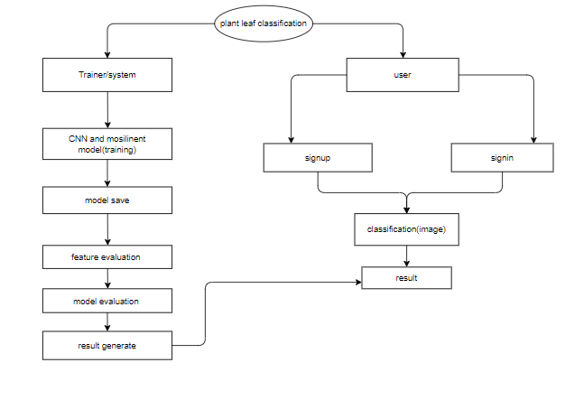
Fig 1. Block diagram of proposed method

4. REQUIREMENT ANALYSIS
4.1 Functional and non-functional requirements
Requirement’s analysis is very critical process that enables the success of a system or software project to be assessed. Requirements are generally split into two types: Functional and non-functional requirements.
Functional Requirements: These are the requirements that the end user specifically demands as basic facilities that the system should offer. All these functionalities need to be necessarily incorporated into the system as a part of the contract. These are represented or stated in the form of input to be given to the system, the operation performed and the output expected. They are basically the requirements stated by the user which one can see directly in the final product, unlike the non-functional requirements.
Examples of functional requirements:
- Authentication of user whenever he/she logs into the system
- System shutdown in case of a cyber-attack
- A verification email is sent to user whenever he/she register for the first time on some software system.
Non-functional requirements: These are basically the quality constraints that the system must satisfy according to the project contract. The priority or extent to which these factors are implemented varies from one project to other. They are also called non-behavioral requirements.
They basically deal with issues like:
- Portability
- Security
- Maintainability
- Reliability
- Scalability
- Performance
- Reusability
- Flexibility
Examples of non-functional requirements:
- Emails should be sent with a latency of no greater than 12 hours from such an activity.
- The processing of each request should be done within 10 seconds
- The site should load in 3 seconds whenever of simultaneous users are > 10000
SYSTEM SPECIFICATIONS:

4.2 H/W Specifications:

Processor : I3/Intel Processor

RAM : 8GB (min)
- Hard Disk : 128 GB
4.3 S/W Specifications:
- Operating System : Windows 10
- Server-side Script : Python 3.6
- IDE : Jupyter Notebook / Pycharm
- Libraries Used : Numpy, IO, OS, keras.

4.4 ARCHITECTURE

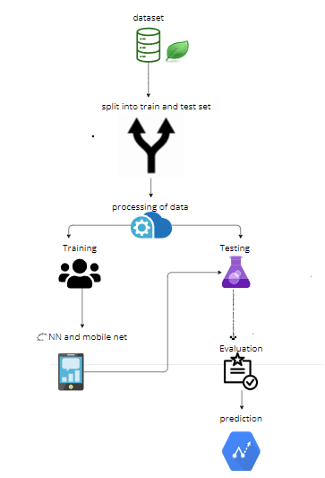
5 . METHODOLOGY AND ALGORITHMS

5.1 Convolutional Neural Network
Step1: convolutional operation
The first building block in our plan of attack is convolution operation. In this step, we will touch on feature detectors, which basically serve as the neural network's filters. We will also discuss feature maps, learning the parameters of such maps, how patterns are detected, the layers of detection, and how the findings are mapped out.

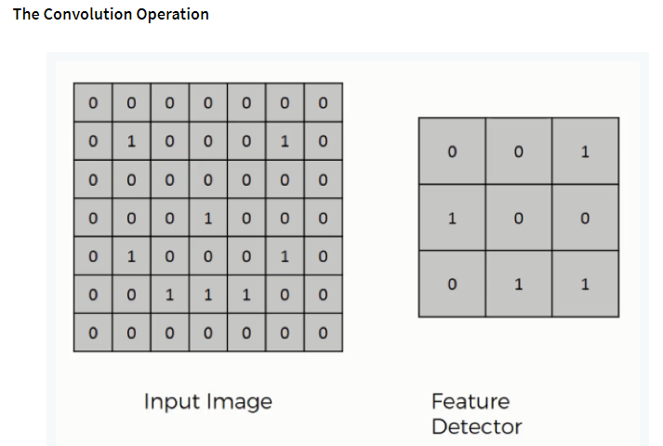
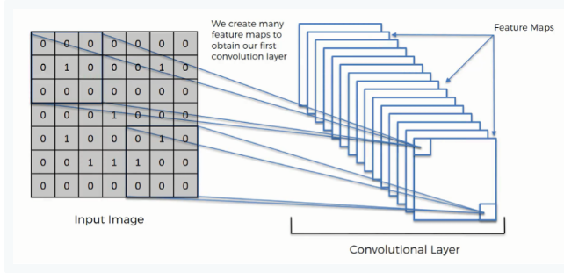
Step (1b): Rule Layer
The second part of this step will involve the Rectified Linear Unit or Relook. We will cover Relook layers and explore how linearity functions in the context of Convolutional Neural Networks.

Not necessary for understanding CNN's, but there's no harm in a quick lesson to improve your skills.

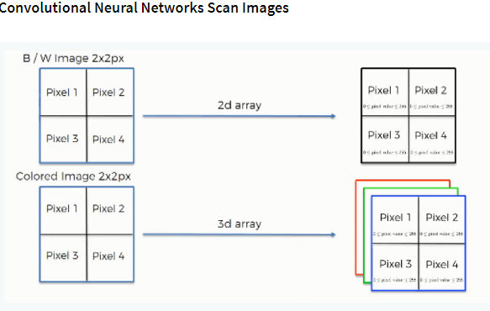

Step 2: Pooling Layer

In this part, we'll cover pooling and will get to understand exactly how it generally works. Our nexus here, however, will be a specific type of pooling; max pooling. We'll cover various approaches, though, including mean (or sum) pooling. This part will end with a demonstration made using a visual interactive tool that will definitely sort the whole concept out for you.

Step 3: Flattening

This will be a brief breakdown of the flattening process and how we move from pooled to flattened layers when working with Convolutional Neural Networks.

Step 4: Full Connection

In this part, everything that we covered throughout the section will be merged together. By learning this, you'll get to envision a fuller picture of how Convolutional Neural Networks operate and how the "neurons" that are finally produced learn the classification of images.

Summary
In the end, we'll wrap everything up and give a quick recap of the concept covered in the section. If you feel like it will do you any benefit (and it probably will), you should check out the extra tutorial in which Soft max and Cross-Entropy are covered. It's not mandatory for the course, but you will likely come across these concepts when working with Convolutional Neural Networks and it will do you a lot of good to be familiar with them.

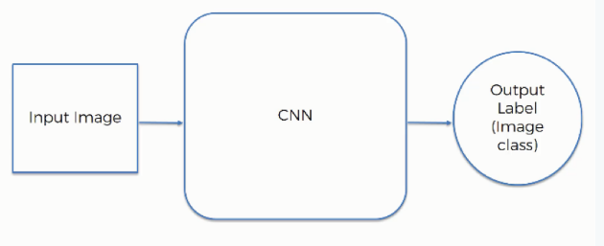

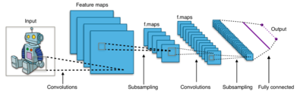

Fig. CNN Architecture

5.2 Mobile Net :
The utilization of Mobile Net algorithm in the detection of plant diseases through machine learning and deep learning is a groundbreaking approach. Mobile Net, known for its efficiency and lightweight architecture, proves to be instrumental in developing robust models for plant disease detection on mobile devices. By leveraging the power of convolutional neural networks (CNNs) within the Mobile Net framework, this technology enables real-time analysis of plant health through image processing.
Mobile Net's capacity to efficiently handle computational tasks on resource-constrained platforms, such as smartphones, facilitates the deployment of portable and accessible plant disease detection solutions. The algorithm's ability to balance accuracy and computational efficiency is crucial in ensuring timely and accurate identification of diseases, empowering farmers and agricultural professionals to take swift corrective actions. Through the amalgamation of Mobile Net and advanced image recognition techniques, this research strives to enhance the efficacy and accessibility of plant disease detection, contributing to sustainable agriculture and food security.
SOFTWARE DEVELOPMENT LIFE CYCLE – SDLC:
In our project we use waterfall model as our software development cycle because of its step-by-step procedure while implementing.

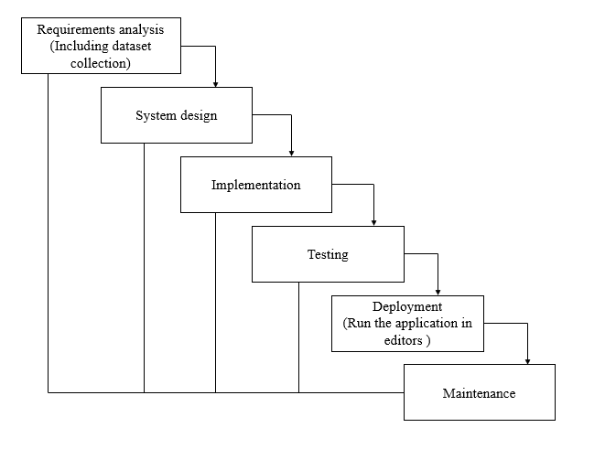
Fig 3: Waterfall Model

- Requirement Gathering and analysis − all possible requirements of the system to be developed are captured in this phase and documented in a requirement specification document.
- System Design − the requirement specifications from first phase are studied in this phase and the system design is prepared. This system design helps in specifying hardware and system requirements and helps in defining the overall system architecture.
- Implementation − with inputs from the system design, the system is first developed in small programs called units, which are integrated in the next phase. Each unit is developed and tested for its functionality, which is referred to as Unit Testing.
- Integration and Testing − All the units developed in the implementation phase are integrated into a system after testing of each unit. Post integration the entire system is tested for any faults and failures.
- Deployment of system − Once the functional and non-functional testing is done; the product is deployed in the customer environment or released into the market.
- Maintenance − There are some issues which come up in the client environment. To fix those issues, patches are released. Also, to enhance the product some better versions are released. Maintenance is done to deliver these changes in the customer environment.
6. SYSTEM DESIGN
6.1 Introduction of Input Design:
In an information system, input is the raw data that is processed to produce output. During the input design, the developers must consider the input devices such as PC, MICR, OMR, etc.
Therefore, the quality of system input determines the quality of system output. Well-designed input forms and screens have following properties −
- It should serve specific purpose effectively such as storing, recording, and retrieving the information.
- It ensures proper completion with accuracy.
- It should be easy to fill and straightforward.
- It should focus on user’s attention, consistency, and simplicity.
- All these objectives are obtained using the knowledge of basic design principles regarding −
  - What are the inputs needed for the system?
  - How end users respond to different elements of forms and screens.

Objectives for Input Design:
The objectives of input design are
- To design data entry and input procedures
- To reduce input volume
- To design source documents for data capture or devise other data capture methods
- To design input data records, data entry screens, user interface screens, etc.
- To use validation checks and develop effective input controls.
Output Design:
The design of output is the most important task of any system. During output design, developers identify the type of outputs needed, and consider the necessary output controls and prototype report layouts.

Objectives of Output Design:
The objectives of input design are:
- To develop output design that serves the intended purpose and eliminates the production of unwanted output.
- To develop the output design that meets the end user’s requirements.
- To deliver the appropriate quantity of output.
- To form the output in appropriate format and direct it to the right person.
- To make the output available on time for making good decisions.
6.2 UML DIAGRAMS
UML stands for Unified Modelling Language. UML is a standardized general-purpose modelling language in the field of object-oriented software engineering. The standard is managed, and was created by, the Object Management Group.
The goal is for UML to become a common language for creating models of object-oriented computer software. In its current form UML is comprised of two major components: a Meta-model and a notation. In the future, some form of method or process may also be added to; or associated with, UML.
The Unified Modelling Language is a standard language for specifying, Visualization, Constructing and documenting the artifacts of software system, as well as for business modelling and other non-software systems.
The UML represents a collection of best engineering practices that have proven successful in the modelling of large and complex systems.
The UML is a very important part of developing objects-oriented software and the software development process. The UML uses mostly graphical notations to express the design of software projects.
GOALS:
The Primary goals in the design of the UML are as follows:
- particular programming languages and development process.
- Provide a formal Provide users a ready-to-use, expressive visual modelling Language so that they can develop and exchange meaningful models.
- Provide extendibility and specialization mechanisms to extend the core concepts.
- Be independent of basis for understanding the modelling language.
- Encourage the growth of OO tools market.
- Support higher level development concepts such as collaborations, frameworks, patterns and components.
- Integrate best practices.
USE CASE DIAGRAM :
- A use case diagram in the Unified Modeling Language (UML) is a type of behavioral diagram defined by and created from a Use-case analysis.
- Its purpose is to present a graphical overview of the functionality provided by a system in terms of actors, their goals (represented as use cases), and any dependencies between those use cases.
- The main purpose of a use case diagram is to show what system functions are performed for which actor. Roles of the actors in the system can be depicted.
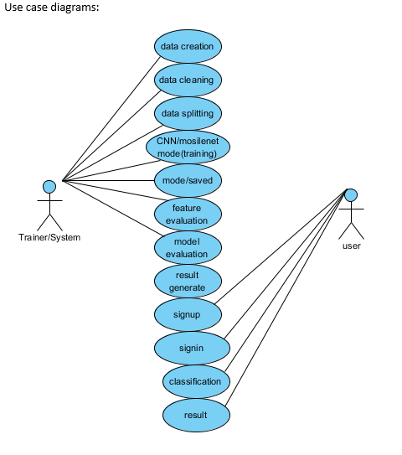

CLASS DIAGRAM :
In software engineering, a class diagram in the Unified Modeling Language (UML) is a type of static structure diagram that describes the structure of a system by showing the system's classes, their attributes, operations (or methods), and the relationships among the classes. It explains which class contains information

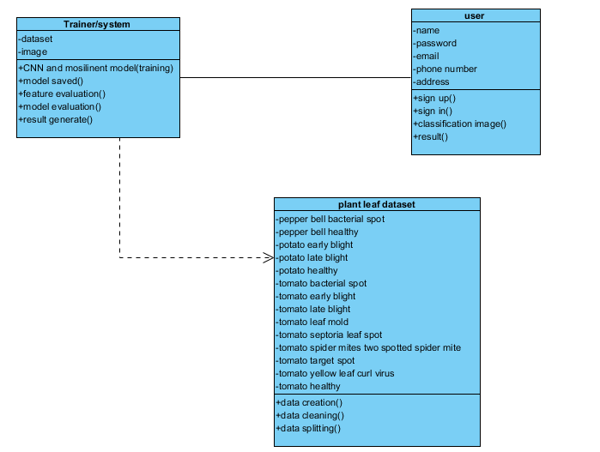
SEQUENCE DIAGRAM :
- A sequence diagram in Unified Modeling Language (UML) is a kind of interaction diagram that shows how processes operate with one another and in what order.
- It is a construct of a Message Sequence Chart. Sequence diagrams are sometimes called event diagrams, event scenarios, and timing diagrams

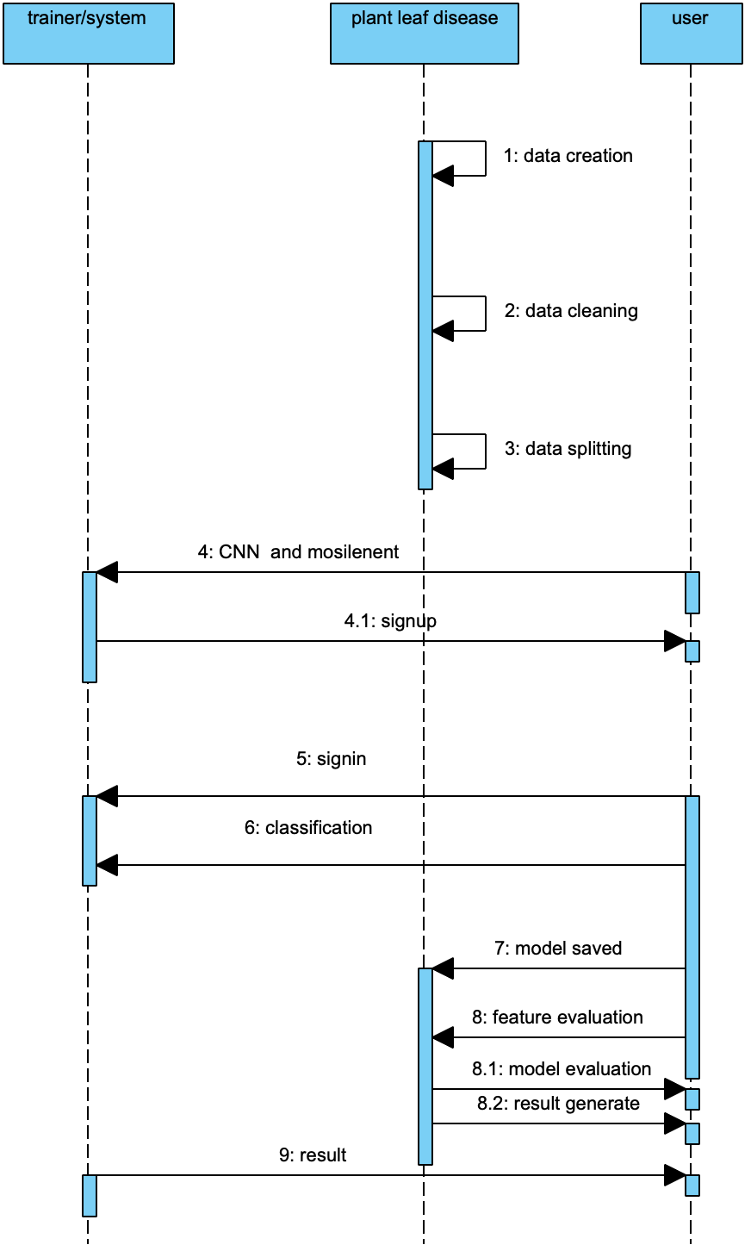
COLLABORATION DIAGRAM:
In collaboration diagram the method call sequence is indicated by some numbering technique as shown below. The number indicates how the methods are called one after another. We have taken the same order management system to describe the collaboration diagram. The method calls are similar to that of a sequence diagram. But the difference is that the sequence diagram does not describe the object organization whereas the collaboration diagram shows the object organization.
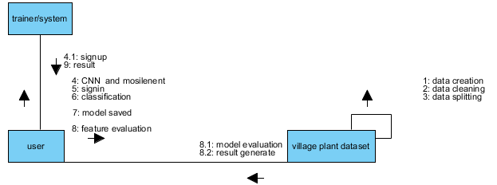
DEPLOYMENT DIAGRAM :
Deployment diagram represents the deployment view of a system. It is related to the component diagram. Because the components are deployed using the deployment diagrams. A deployment diagram consists of nodes. Nodes are nothing but physical hardware’s used to deploy the application.
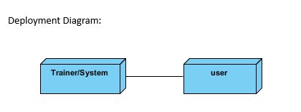
ACTIVITY DIAGRAM :
Activity diagrams are graphical representations of workflows of stepwise activities and actions with support for choice, iteration and concurrency. In the Unified Modeling Language, activity diagrams can be used to describe the business and operational step-by-step workflows of components in a system. An activity diagram shows the overall flow of control.
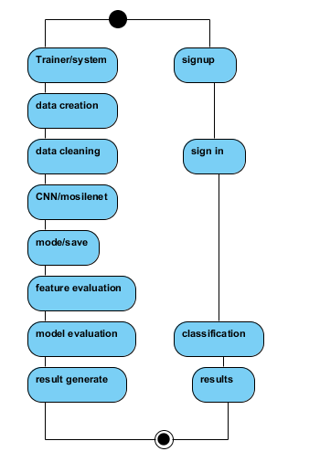
State Machine diagram:
State machine diagram typically are used to describe state-dependent behaviour for an object. An object responds differently to the same event depending on what state it is in.
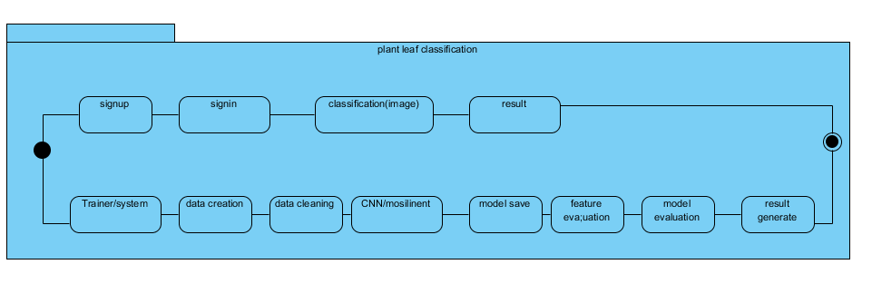

COMPONENT DIAGRAM :
A component diagram, also known as a UML component diagram, describes the organization and wiring of the physical components in a system. Component diagrams are often drawn to help model implementation details and double-check that every aspect of the system's required function is covered by planned development.
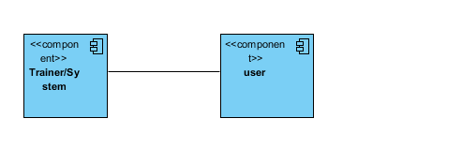

ER DIAGRAM :
An Entity–relationship model (ER model) describes the structure of a database with the help of a diagram, which is known as Entity Relationship Diagram (ER Diagram). An ER model is a design or blueprint of a database that can later be implemented as a database. The main components of E-R model are: entity set and relationship set.
An ER diagram shows the relationship among entity sets. An entity set is a group of similar entities and these entities can have attributes. In terms of DBMS, an entity is a table or attribute of a table in database, so by showing relationship among tables and their attributes, ER diagram shows the complete logical structure of a database. Let’s have a look at a simple ER diagram to understand this concept.

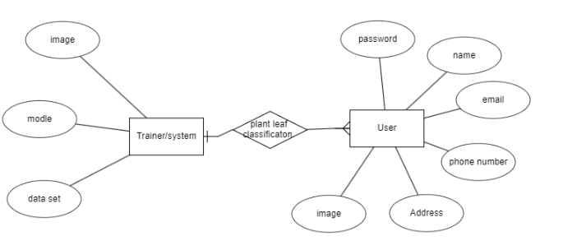
6.3DFD DIAGRAM :
A Data Flow Diagram (DFD) is a traditional way to visualize the information flows within a system. A neat and clear DFD can depict a good amount of the system requirements graphically. It can be manual, automated, or a combination of both. It shows how information enters and leaves the system, what changes the information and where information is stored. The purpose of a DFD is to show the scope and boundaries of a system as a whole. It may be used as a communications tool between a systems analyst and any person who plays a part in the system that acts as the starting point for redesigning a system.
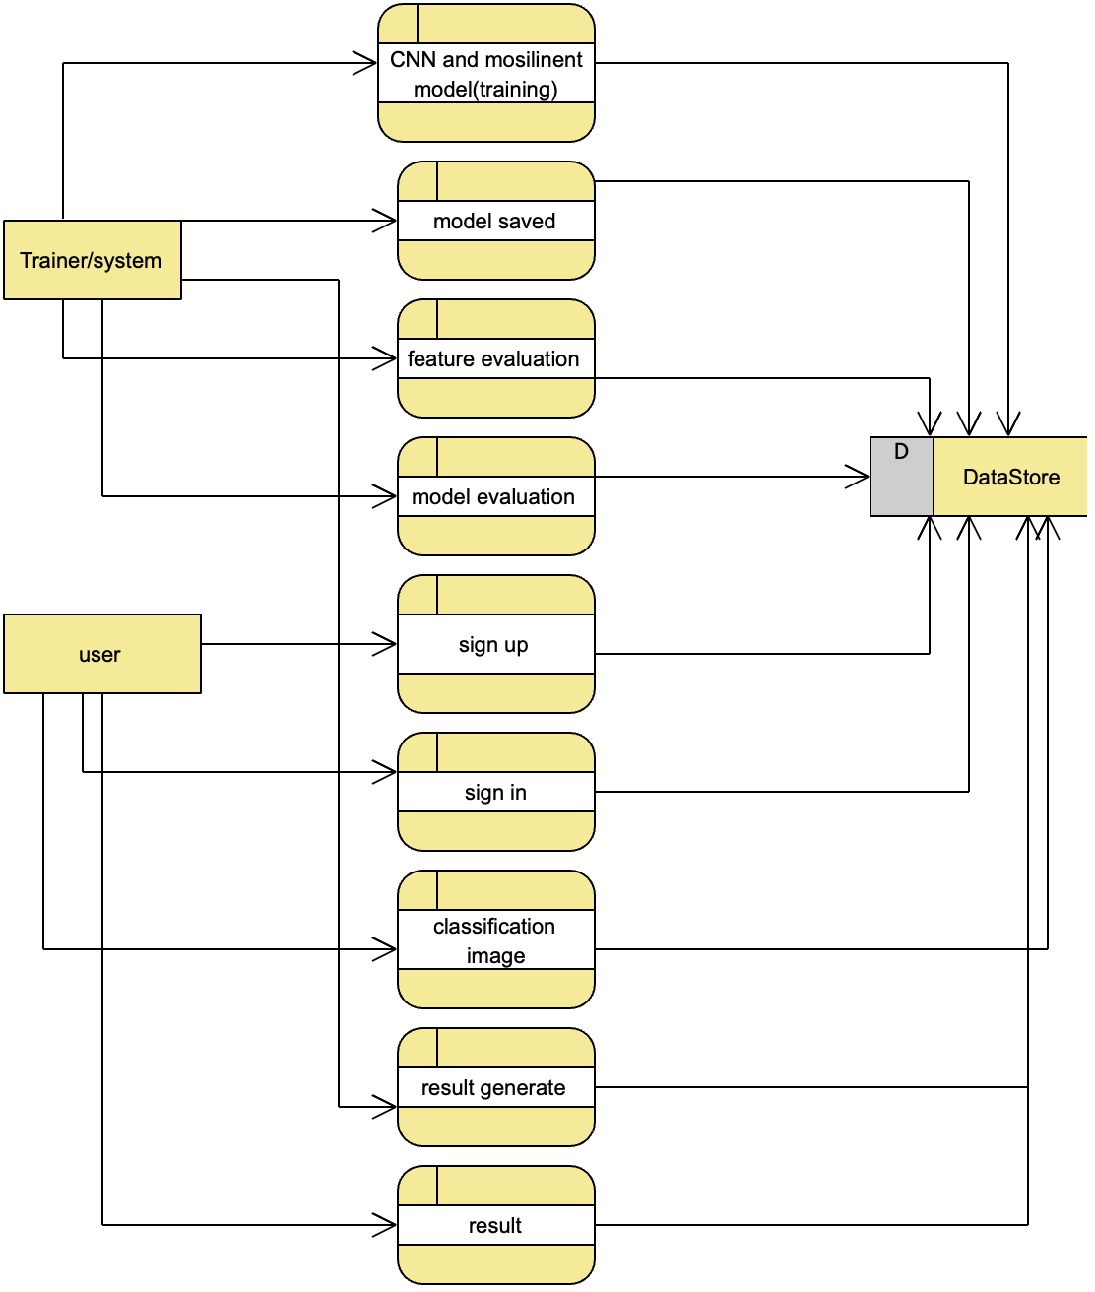
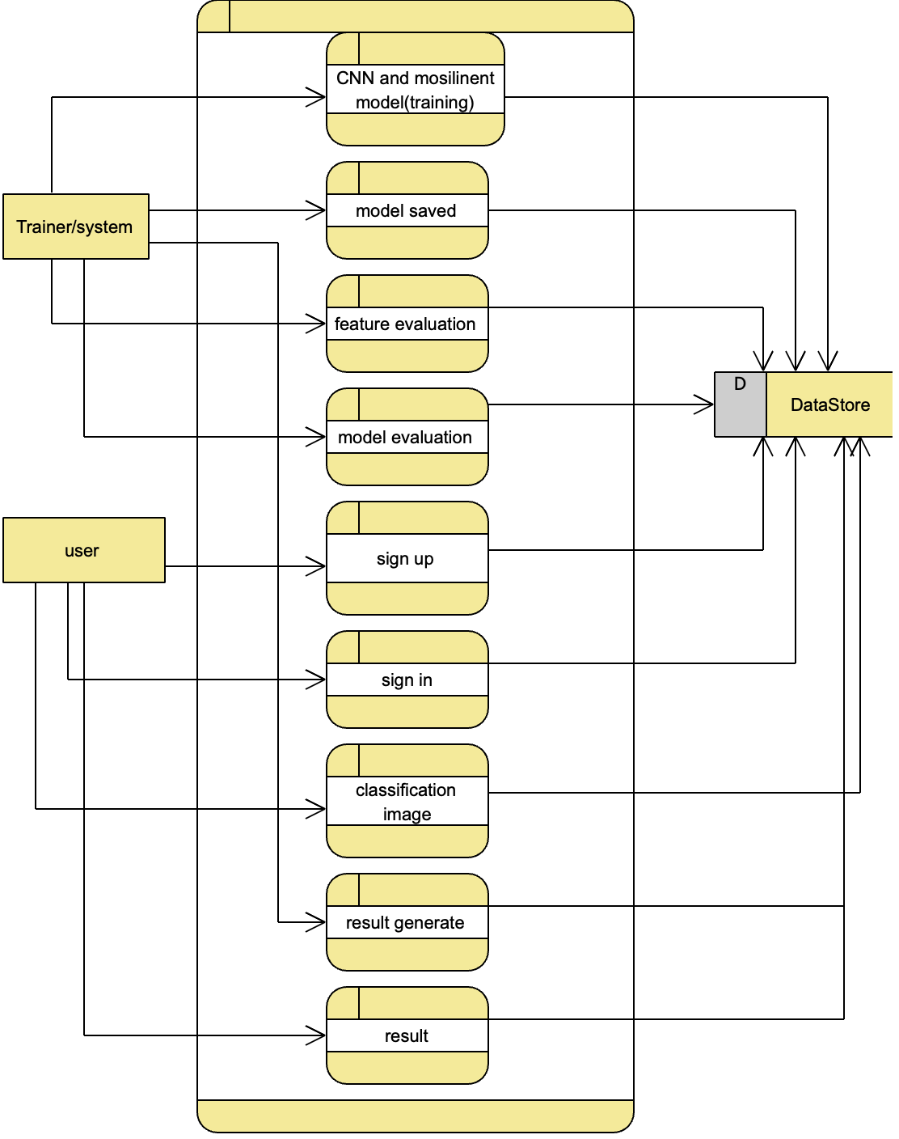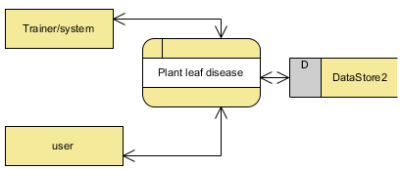
7. IMPLEMENTATION AND RESULTS
7.1 MODULES:
System
User
1. System:
1.1 Create Dataset:
The dataset containing images of the plant leaf images which are normal and effected with disease are split into training and testing dataset with the test size of 30-20%.
1.2 Pre-processing:
Resizing and reshaping the images into appropriate format to train our model.
1.3 Training:
Use the pre-processed training dataset is used to train our model using machine learning (SVM) and deep learning (CNN, Mobile Net) algorithms
1.4 Classification:
The results of our model is predicted output along with the accuracy comparison.
2. User:
2.1 View training accuracy
User can check the trained algorithms accuracy
2.2 Upload Image
The user has to upload an image which needs to be classified.
2.3 View Results and precautions
The classified image results are viewed by user along with precautions.
7.2 output screens:

8. SYSTEM STUDY AND TESTING
8.1 Feasibility Study
The feasibility of the project is analysed in this phase and business proposal is put forth with a very general plan for the project and some cost estimates. During system analysis the feasibility study of the proposed system is to be carried out. This is to ensure that the proposed system is not a burden to the company. For feasibility analysis, some understanding of the major requirements for the system is essential.
Three key considerations involved in the feasibility analysis are
- Economical feasibility
- Technical feasibility
- Social feasibility
Economical Feasibility
This study is carried out to check the economic impact that the system will have on the organization. The amount of fund that the company can pour into the research and development of the system is limited. The expenditures must be justified. Thus the developed system as well within the budget and this was achieved because most of the technologies used are freely available. Only the customized products had to be purchased.

Technical Feasibility
This study is carried out to check the technical feasibility, that is, the technical requirements of the system. Any system developed must not have a high demand on the available technical resources. This will lead to high demands on the available technical resources. This will lead to high demands being placed on the client. The developed system must have a modest requirement, as only minimal or null changes are required for implementing this system.
Social Feasibility
The aspect of study is to check the level of acceptance of the system by the user. This includes the process of training the user to use the system efficiently. The user must not feel threatened by the system, instead must accept it as a necessity. The level of acceptance by the users solely depends on the methods that are employed to educate the user about the system and to make him familiar with it. His level of confidence must be raised so that he is also able to make some constructive criticism, which is welcomed, as he is the final user of the system.

System Testing
The purpose of testing is to discover errors. Testing is the process of trying to discover every conceivable fault or weakness in a work product. It provides a way to check the functionality of components, sub-assemblies, assemblies and/or a finished product It is the process of exercising software with the intent of ensuring that the
Software system meets its requirements and user expectations and does not fail in an unacceptable manner. There are various types of test. Each test type addresses a specific testing requirement.

8.2 Types of Tests

8.2.1 Unit testing
Unit testing involves the design of test cases that validate that the internal program logic is functioning properly, and that program inputs produce valid outputs. All decision branches and internal code flow should be validated. It is the testing of individual software units of the application .it is done after the completion of an individual unit before integration. This is a structural testing, that relies on knowledge of its construction and is invasive. Unit tests perform basic tests at component level and test a specific business process, application, and/or system configuration. Unit tests ensure that each unique path of a business process performs accurately to the documented specifications and contains clearly defined inputs and expected results.

8.2.2 Integration testing
Integration tests are designed to test integrated software components to determine if they actually run as one program. Testing is event driven and is more concerned with the basic outcome of screens or fields. Integration tests demonstrate that although the components were individually satisfaction, as shown by successfully unit testing, the combination of components is correct and consistent. Integration testing is specifically aimed at exposing the problems that arise from the combination of components.
Software integration testing is the incremental integration testing of two or more integrated software components on a single platform to produce failures caused by interface defects.
The task of the integration test is to check that components or software applications, e.g. components in a software system or – one step up – software applications at the company level – interact without error.
Test Results: All the test cases mentioned above passed successfully. No defects encountered.

Acceptance Testing
User Acceptance Testing is a critical phase of any project and requires significant participation by the end user. It also ensures that the system meets the functional requirements.
Test Results: All the test cases mentioned above passed successfully. No defects encountered.

8.2.3 Functional testing
Functional tests provide systematic demonstrations that functions tested are available as specified by the business and technical requirements, system documentation, and user manuals.
Functional testing is centered on the following items:
Valid Input : identified classes of valid input must be accepted.
Invalid Input : identified classes of invalid input must be rejected.
Functions : identified functions must be exercised.
Output : identified classes of application outputs must be exercised.
Systems/Procedures: interfacing systems or procedures must be invoked.
Organization and preparation of functional tests is focused on requirements, key functions, or special test cases. In addition, systematic coverage pertaining to identify Business process flows; data fields, predefined processes, and successive processes must be considered for testing. Before functional testing is complete, additional tests are identified and the effective value of current tests is determined.

8.2.4 White Box Testing
White Box Testing is a testing in which in which the software tester has knowledge of the inner workings, structure and language of the software, or at least its purpose. It is purpose. It is used to test areas that cannot be reached from a black box level.

8.2.5 Black Box Testing
Black Box Testing is testing the software without any knowledge of the inner workings, structure or language of the module being tested. Black box tests, as most other kinds of tests, must be written from a definitive source document, such as specification or requirements document, such as specification or requirements document. It is a testing in which the software under test is treated, as a black box .you cannot “see” into it. The test provides inputs and responds to outputs without considering how the software works.
Test objectives
- All field entries must work properly.
- Pages must be activated from the identified link.
- The entry screen, messages and responses must not be delayed.
Features to be tested
- Verify that the entries are of the correct format
- No duplicate entries should be allowed
- All links should take the user to the correct page.
TEST CASES:
Input | Output | Result
Input image | Tested for the classification of given input leaf image | Success

Test cases Model building:
S.NO | Test cases | I/O | Expected O/T | Actual O/T | P/F
1 | Read the dataset. | Dataset path. | Dataset need to read successfully. | Dataset fetched successfully. | P
2 | Performing pre-processing on the dataset | Pre-processing part takes place | Pre-processing should be performed on dataset | Pre-processing successfully completed. | P
3 | Model Building | Model Building for the clean data | Need to create model using required algorithms | Model Created Successfully. | P
4 | Classification | Input image provided. | Output should be the classified output of the leaf image | Model classified successfully | P
5 | Precautions | Precautions to classified output | To the classified output image precautions are to be provided if it is detected as diseased leaf | Precautions are provided successfully | P

    - CONCLUSION

In this project we have successfully implemented the machine learning and deep learning algorithms to build a model that which can predict the plant leaf images, either the leaf is effected with which type of disease or not. Here we mainly used CNN, MobileNet, SVM, and ResNet for the process of training image dataset. Once after training, we have checked the classified results for the provided input image and then the precautions are provided for the diseased leaf.

10 FUTURE SCOPE
This can be utilized in future to classify and predict the disease of the plants easily. This type of process can save more human efforts and works accurately.
11 REFERENCES
[1] Monica Jhuria, Ashwini Kumar, Rushikesh Borse “Image Processing for Smart Farming: Detection of Disease and Fruit Grading” Proceeding of the 2013 IEEE Second International Conference on Image Processing.
[2] Sudhir Rao Rupanagudi, Ranjani B.S., Prathik Nagaraj, Varsha G. Bhat “A Cost Effective Tomato Maturity Grading System using Image Processing for 974 2015 International Conference on Green Computing and Internet of Things (ICGCIoT) Farmers” International Conference on Contemporary Computing and Information, 2014.
[3] Shiv Ram Dubey, Anand Singh Jalal “Adapted Approach for Fruit Disease Identification using Images”.
[4] Manisha A. Bhange, Prof. H. A. Hingoliwala “A Review of Image Processing for Pomegranate Disease Detection” International Journal of Computer Science and Information Technologies, Vol. 6 (1), 2015, 92-94.
[5] Hetal N. Patel, Dr. M. V. Joshi “Fruit Detection using Improved Multiple Features based Algorithm” International Journal of Computer Applications (0975 – 8887), Volume 13– No.2, January 2011.
[6] Abraham Gastélum-Barrios, Rafael A. BorquezLópez, Enrique Rico-García, Manuel ToledanoAyala and Genaro M. Soto-Zarazúa* “Tomato Quality Evaluation with Image processing: A review” African Journal of Agricultural Research Vol. 6(14), pp. 3333-3339, 18 July, 2011.
[7] H. Al-Hiary, S. Bani-Ahmad, M. Reyalat, M. Braik and Z. ALRahamneh “Fast and Accurate Detection and Classification of Plant Diseases” International Journal of Computer Applications (0975 – 8887) Volume 17– No.1, March 2011.
[8] P. Vimala Devi and K. Vijayarekha “Machine Vision Application to Locate Fruits, Detect Defects and Remove Noise: A Review” Vol.7 | No.1 | 104-113| January – March | 2014.
[9] Shiv Ram Dubey, A. S. Jalal “Detection and Classification of Apple Fruit Diseases using Complete Local Binary Patterns”.
[10] Rashmi Pandey, Sapan Naik, Roma Marfatia “Image Processing and Machine Learning for Automated Fruit Grading System: A Technical Review” International Journal of Computer Applications (0975 – 8887) Volume 81 – No 16, November 2013.
[11] Anshuka Srivastava, Swapnil Kumar Sharma “Development of a Robotic Navigator to Assist the Farmer in Field” Proceeding of the International Multi Conference of Engineers and Computer Scientists 2010 Vol. (2) IMECS 2010 March 17-19, Hong Kong.
[12] Savita N. Ghaiwat, Parul Arora “Detection and Classification of Plant Leaf Diseases Using Image processing Techniques: A Review” International Journal of Recent Advances in Engineering & Technology (IJRAET) ISSN (Online): 2347 - 2812, Volume-2, Issue - 3, 2014.
[13]Anand H. Kulkarni, Ashwin Patil R. K. “Applying image processing technique to detect plant diseases” International Journal of Modern Engineering Research (IJMER) Vol.2, Issue.5, Sep-Oct. 2012 pp3661-3664 .
[14]Pradnya Ravindra Narvekar, Mahesh Manik Kumbhar2, S. N. Patil “Grape Leaf Diseases Detection & Analysis using SGDM Matrix Method” International Journal of Innovative Research in Computer and Communication Engineering (An ISO 3237:2007 certified organization ) Vol.2,Issue 3, March 2014.
[15] Tejal Deshpande, Sharmila Sengupta, K. S. Raghuvanshi “Grading & Identification of Disease in Pomegranate Leaf and Fruit” International Journal of Computer Science and Information Technologies, Vol. 5 (3), 2014, 4638-4645.
[16] Vinita Tajane, Prof. N.J. Janwe “Medicinal Plants Disease Identification Using Canny Edge Detection Algorithm, Histogram Analysis and CBIR” International Journal of Advanced Research in Computer Science and Software Engineering, Volume 4, Issue 6, June 2014.
[17]Jayamala K. Patil, Raj Kumar “Advances in Image Processing for Detection of Plant Disease” Journal of Advanced Bioinformatics Applications and Research ISSN 0976-2604 Vol. 2, Issue 2, June-2011, 135- 141.
[18]Shiv Ram Dubey, Pushkar Dixit, Nishant Singh, Jay Prakash Gupta “Infected Fruit Part Detection using K-Means Clustering Segmentation Technique” International Journal of Artificial Intelligence and Interactive Multimedia, Vol. 2, 2013.

